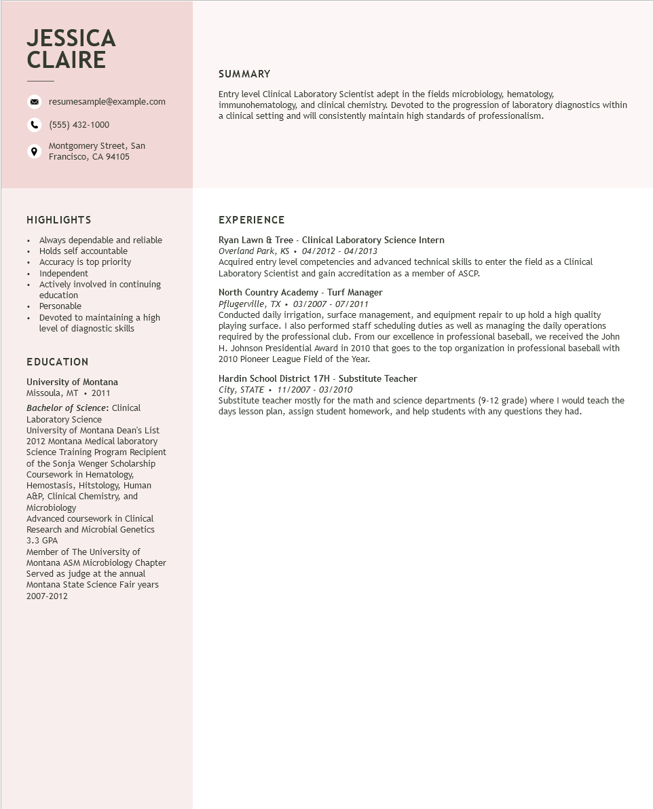
JESSICA CLAIRE
resumesample@example.com
(555) 432-1000
Montgomery Street, San
Francisco, CA 94105
SUMMARY
Entry level Clinical Laboratory Scientist adept in the fields microbiology, hematology, immunohematology, and clinical chemistry. Devoted to the progression of laboratory diagnostics within a clinical setting and will consistently maintain high standards of professionalism.
HIGHLIGHTS
Always dependable and reliable
.
•
Holds self accountable
•
•
+
•
Accuracy is top priority Independent
Actively involved in continuing education
Personable
Devoted to maintaining a high
level of diagnostic skills
EDUCATION
University of Montana Missoula, MT. 2011
Bachelor of Science: Clinical Laboratory Science
University of Montana Dean's List 2012 Montana Medical laboratory Science Training Program Recipient of the Sonja Wenger Scholarship Coursework in Hematology, Hemostasis, Hitstology, Human A&P, Clinical Chemistry, and Microbiology
Advanced coursework in Clinical Research and Microbial Genetics 3.3 GPA
Member of The University of
Montana ASM Microbiology Chapter
Served as judge at the annual Montana State Science Fair years 2007-2012
EXPERIENCE
Ryan Lawn & Tree - Clinical Laboratory Science Intern
Overland Park, KS 04/2012 - 04/2013
Acquired entry level competencies and advanced technical skills to enter the field as a Clinical Laboratory Scientist and gain accreditation as a member of ASCP.
North Country Academy - Turf Manager
Pflugerville, TX. 03/2007 - 07/2011
Conducted daily irrigation, surface management, and equipment repair to up hold a high quality playing surface. I also performed staff scheduling duties as well as managing the daily operations required by the professional club. From our excellence in professional baseball, we received the John H. Johnson Presidential Award in 2010 that goes to the top organization in professional baseball with 2010 Pioneer League Field of the Year.
Hardin School District 17H - Substitute Teacher
City, STATE
11/2007-03/2010
Substitute teacher mostly for the math and science departments (9-12 grade) where I would teach the days lesson plan, assign student homework, and help students with any questions they had.

